# [**Christopher Meloni's SVU Spin-Off Law & Order: Organized Crime Delayed Until 2021**](https://www.tvguide.com/amp/news/christopher-meloni-svu-spin-off-law-order-organized-crime-delayed-2021/?__twitter_impression=true&s=09)

MountainsBY [**SADIE GENNIS**](https://www.tvguide.com/authors/sadie-gennis/)[**@SADIEGENNIS**](https://www.twitter.com/sadiegennis)AUG 27, 2020 5:16 PM EDT



*Law & Order: SVU* Guest Stars Recall Their Roles

[**Christopher Meloni**](https://www.tvguide.com/celebrities/christopher-meloni/144798/)'s Elliot Stabler spin-off, [***Law & Order: Organized Crime***](https://www.tvguide.com/tvshows/law-order-organized-crime/1471858/), has been delayed. The anticipated drama was expected to debut this October on NBC, following [***Law & Order: SVU,***](https://www.tvguide.com/tvshows/law-order-special-victims-unit/100257/) but NBC announced Thursday that the show was being pushed until 2021.

*Law & Order: Organized Crime* centers on Stabler returning to the NYPD to lead the organized crime division "after a devastating personal loss," per the show's official description. "However, the city and police department have changed dramatically in the decade he's been away, and he must adapt to a criminal justice system in the midst of its own moment of reckoning. Throughout the series, we will follow Stabler's journey to find absolution and rebuild his life, while leading a new elite task force that is taking apart the city's most powerful criminal syndicates one by one." [**Dick Wolf**](https://www.tvguide.com/celebrities/dick-wolf/194137/#link={%22role%22:%22standard%22,%22href%22:%22https://www.tvguide.com/celebrities/dick-wolf/194137/%22,%22target%22:%22%22,%22absolute%22:%22%22,%22linkText%22:%22Dick%20Wolf%22}) will executive produce, with [***Chicago P.D.***](https://www.tvguide.com/tvshows/chicago-pd/556344/#link={%22role%22:%22standard%22,%22href%22:%22https://www.tvguide.com/tvshows/chicago-pd/556344/%22,%22target%22:%22%22,%22absolute%22:%22%22,%22linkText%22:%22Chicago%20P.D.%22})'s [**Matt Olmstead**](https://www.tvguide.com/celebrities/matt-olmstead/283017/#link={%22role%22:%22standard%22,%22href%22:%22https://www.tvguide.com/celebrities/matt-olmstead/283017/%22,%22target%22:%22%22,%22absolute%22:%22%22,%22linkText%22:%22Matt%20Olmstead%22}) serving as showrunner.

[**Everything We Know About Elliot Stabler Spin-Off *Law & Order: Organized Crime***](https://www.tvguide.com/news/christopher-meloni-elliot-stabler-law-order-svu-spin-off/)

While the Stabler spin-off has been pushed until 2021, NBC revealed that *SVU* will still debut this fall, with Season 22 set to premiere on Thursday, Nov. 12 at 9/8c. *SVU* showrunner [**Warren Leight**](https://www.tvguide.com/celebrities/warren-leight/183309/#link={%22role%22:%22standard%22,%22href%22:%22https://www.tvguide.com/celebrities/warren-leight/183309/%22,%22target%22:%22%22,%22absolute%22:%22%22,%22linkText%22:%22Warren%20Leight%22}) previously stated on NBC'spodcast [***The Squadroom***](https://art19.com/shows/the-law-order-svu-podcast/episodes/e455aaeb-2b27-46e3-b43b-c091a927fbc7#link={%22role%22:%22standard%22,%22href%22:%22https://art19.com/shows/the-law-order-svu-podcast/episodes/e455aaeb-2b27-46e3-b43b-c091a927fbc7%22,%22target%22:%22%22,%22absolute%22:%22%22,%22linkText%22:%22The%20Squadroom%22})that Stabler will appear in *SVU*'s season premiere before the spin-off debuts. It's unknown whether *Organized Crime*'s delay will affect those plans or if we'll still see Stabler on our screens again this fall.

*Law & Order: SVU* is available to stream on [**Hulu**](https://click.linksynergy.com/fs-bin/click?id=Bs9ZhlULz2w&offerid=615841.58&type=3&subid=editorial).

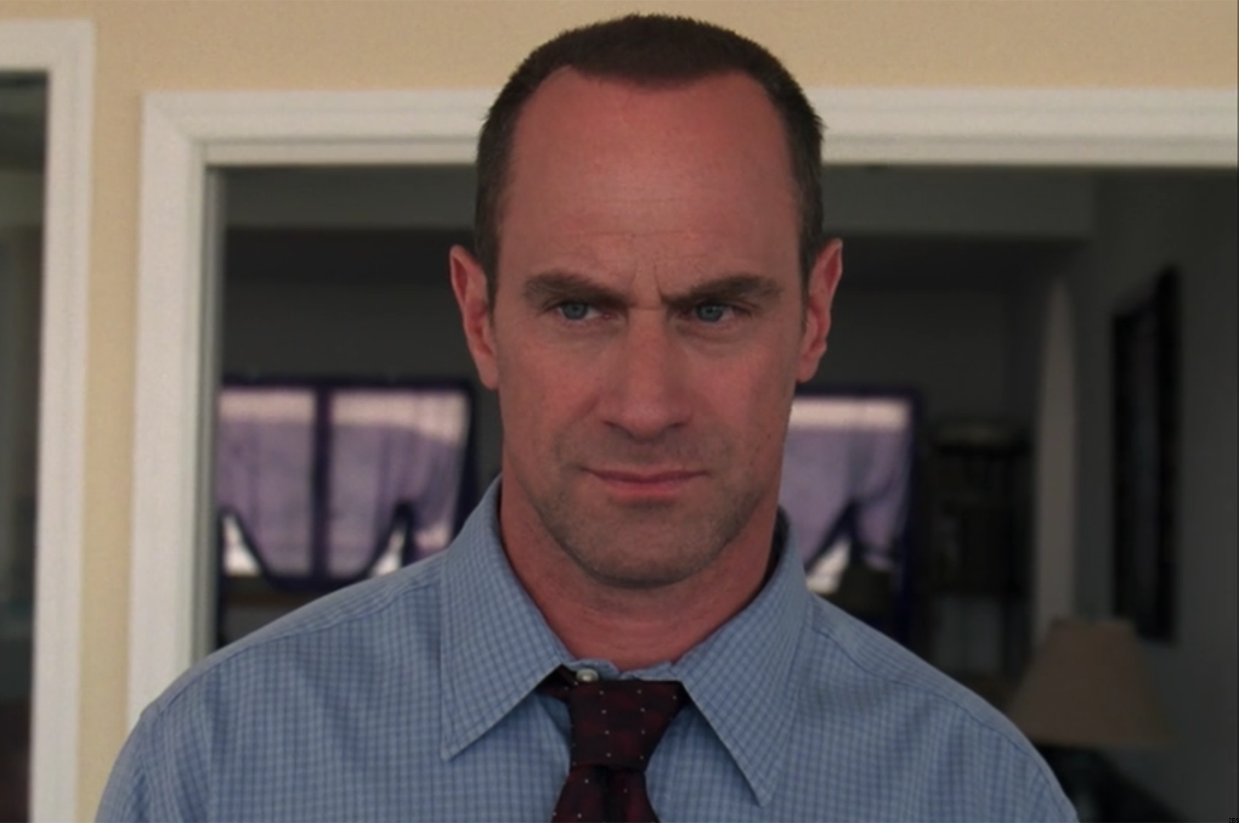Christopher Meloni, *Law & Order: SVU*

(*Disclosure: TV Guide is owned by CBS Interactive, a division of ViacomCBS.*)